

POKEDEX SELECTION BY NAME

TEAM BATTLE

SELECT 6 POKEMON (SAVE OPTION FOR LATER USE) battle against either a team pulled from another org or a randomly generated team of 6

DISPLAY RELEVANT INFORMATION ABOUT POKEMON

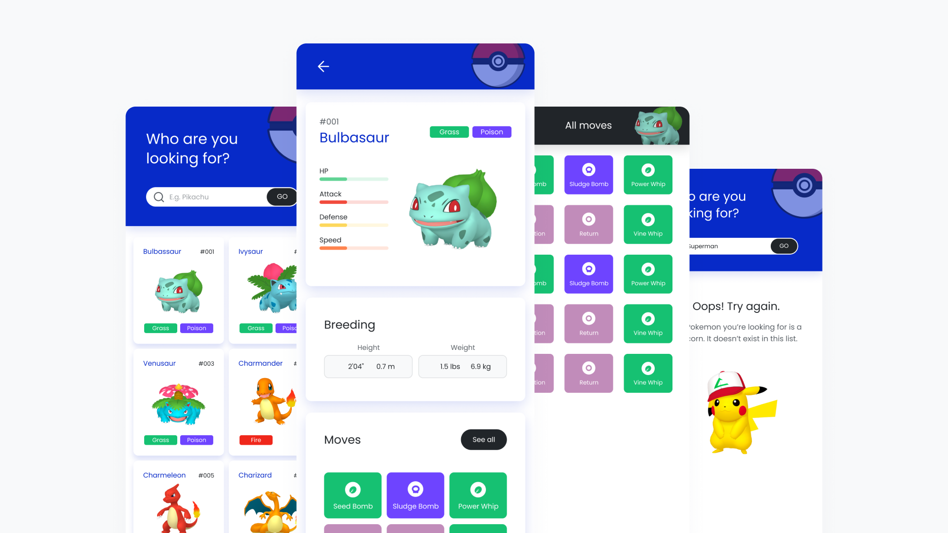

SELECT TWO TO BATTLE (EX: CHARMELEON VS CHARIZARD)

SIMULATE BATTLE-apply a move to lose power, strength, or ability

DISPLAY CHARIZARD WINS! 